
Term work

on
Computer Based Numerical and Statistical Techniques

( PMA 402) 2020-21
Submitted to : Submitted by:
Ms. Preeti Chaudary Aman Gupta
Assistant Professor University Roll.No.: 19011909
GEHU, D.Dun Class Roll.No. : 67
Section: F

DEPARTMENT OF COMPUTER SCIENCE AND ENGINEERING
GRAPHIC ERA HILL UNIVERSITY, DEHRADUN

ACKNOWLEDGMENT
I would like to particularly thank my CBNST Lab Faculty Ms. Preeti Chaudary for his patience, support and encouragement throughout the completion of this Term work.
At last but not the least I greatly indebted to all other persons who directly or indirectly helped me during this course.
Aman Gupta
Uni. Roll No.- 19011909
B.Tech CSE-F-IV Sem
Session: 2020-2021
GEHU Dehradun




Table of Contents

Program No. | Program Name | Page No
1 | Program for finding Errors | 4
2 | Program for Bisection Method | 6
3 | Program for Regula Falsi Method | 11
4 | Program for Secant Method | 15
5 | Program for Iteration Method | 19
6 | Program for Newton Raphson Method | 24
7 | Program for Gauss Elimination Method | 28
8 | Program for Gauss Jordan Method | 34
9 | Program for Gauss Jacobi Method | 39
10 | Program for Gauss Seidel Method | 44
11 | Program for Newton Forward Interpolation Method | 48
12 | Program for Newton Backward Interpolation Method | 53
13 | Program for Lagrange’s Interpolation Method | 58
14 | Program for Trapezoidal Rule | 62
15 | Program for Simpson’s 1/3 Rule | 65
16 | Program for Simpson’s 3/8 Rule | 68
17 | Program to Fit a Line | 71
18 | Program to Fit a Parabola | 77

Program 1

Objective: Program to find error
Algorithm:
- Start
- Take input say True value and Approximate value
- Calculate absolute error using formula-
  - Absolute error= True value -Approximate value
- Calculate relative error using formula-
  - relative error= Approximate value/ True value
- Calculate percentage error using formula
  - Percentage error=relative error *100
- Stop

Source Code
#include<stdio.h>
#include<math.h>
int main()
{
float abserror, relerror, percerror, trueval, approxval;
printf("Enter True value");
scanf("%f",&trueval);
printf("Enter approx value");
scanf("%f",&approxval);
abserror=fabs(trueval-approxval);
relerror=abserror/trueval;
percerror=relerror*100;
printf("\nabsolute error = %f\n",abserror);
printf("\nrelative error = %f\n",relerror);
printf("\npercentage error = %f\n",percerror);
return 0;
}

Output
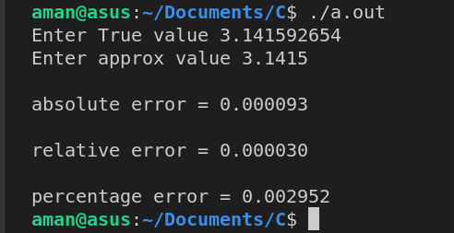
Program 2

Objective: Program to Implement Bisection Method
Algorithm:
- Start
- Read x1, x2, e
*Here x1 and x2 are initial guesses
e is the absolute error i.e. the desired degree of accuracy*
- Compute: f1 = f(x1) and f2 = f(x2)
- If (f1*f2) > 0, then display initial guesses are wrong and goto (11).
Otherwise continue.
- x = (x1 + x2)/2
- If ( [ (x1 – x2)/x ] < e ), then display x and goto (11).
* Here [ ] refers to the modulus sign. *
- Else, f = f(x)
- If ((f*f1) > 0), then x1 = x and f1 = f.
- Else, x2 = x and f2 = f.
- Goto (5).
*Now the loop continues with new values.*
11.Stop

Source Code
#include<stdio.h>
#include<math.h>

float f(float x)
{
return(x*x*x-x-1);
}

int main(void)
{
printf("x^3-8");
float x, x1, x2, err, y;
do
{
printf("\nEnter initial approximaion x1 & x2 : ");
scanf("%f%f",&x1,&x2);
}while(f(x1)*f(x2)>=0);
printf("\nEnter Alowwed Error : ");
scanf("%f",&err);
int itr=1;
y=x1;
printf("\n\nf( %f ) = %f ",x1,f(x1));
printf("\n\nf( %f ) = %f ",x2,f(x2));
while(1)
{
x=(x1+x2)/2;
if(fabs(x-y)<err)
{
printf("\nResult after %d iterations root x : %f\n",itr,x);
break;
}
if(f(x)*f(x2)<0)
x1=x;
else if(f(x1)*f(x)<0)
x2=x;
y=x;
printf("\n\n%d iteration x : %f",itr,x);
printf("\nf( %f ) = %f ",x,f(x));
itr++;
}
return 0;
}

Output

Bisection Method
Or
Bolzano Method

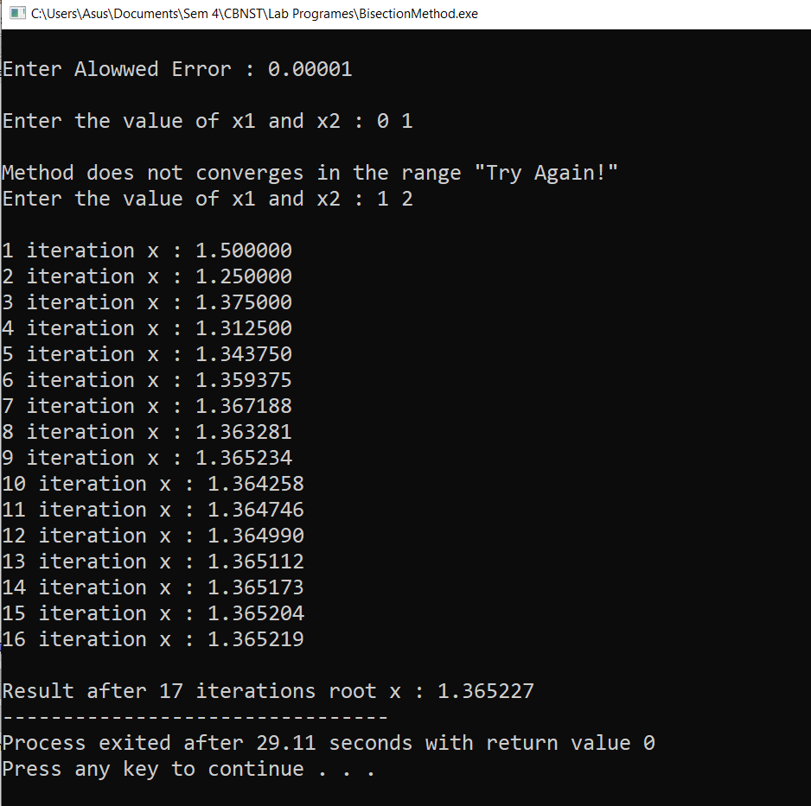
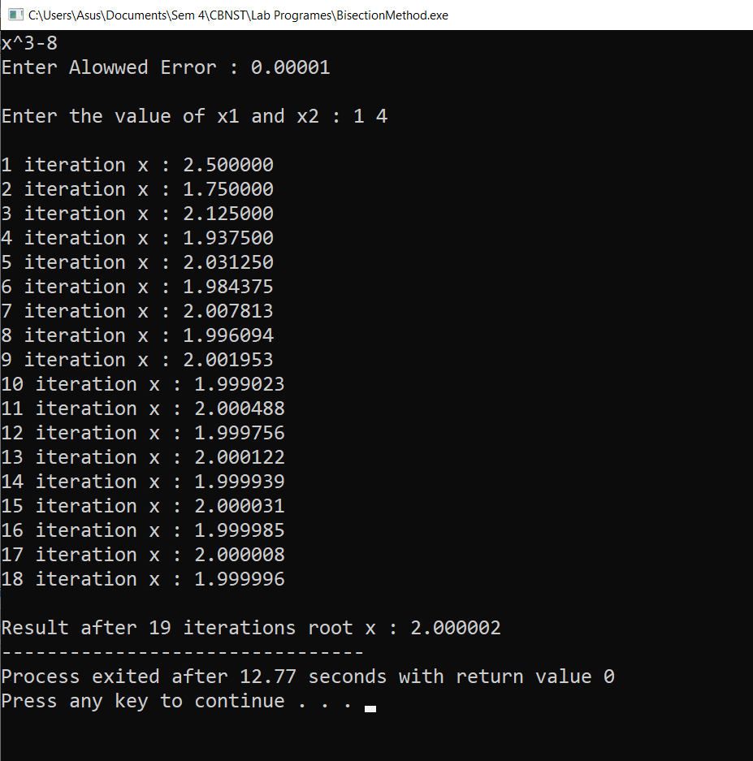
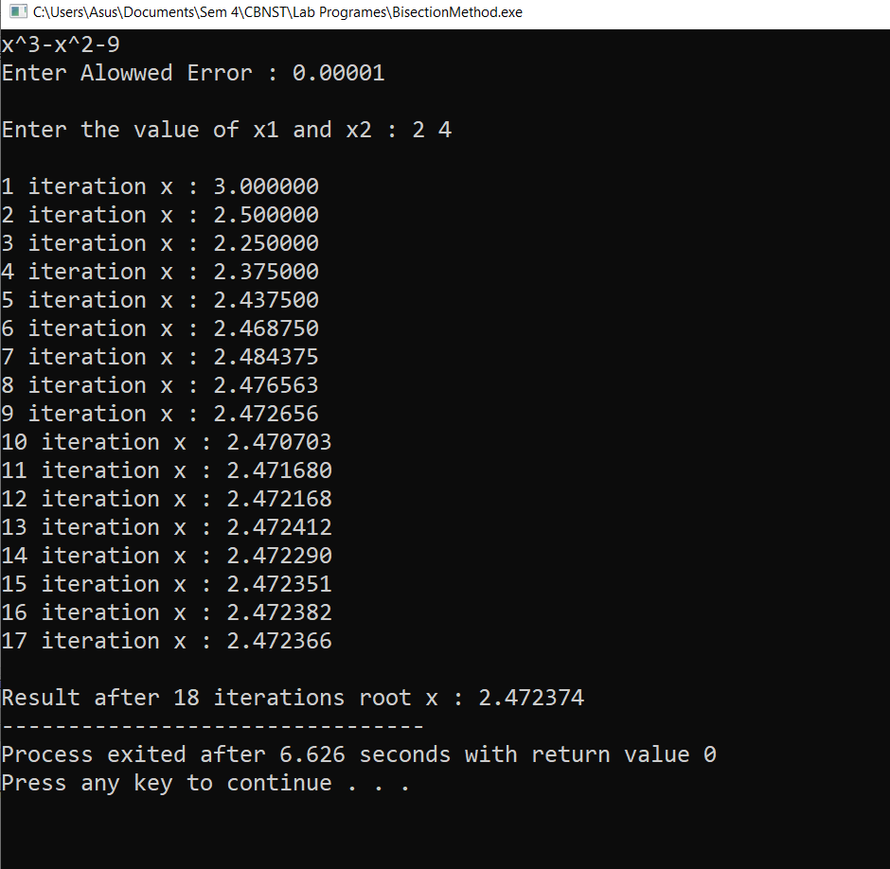
Program 3

Objective: Program to Implement Regular Falsi Method
Algorithm:
- Start
- Read values of x0, x1 and e
*Here x0 and x1 are the two initial guesses
e is the degree of accuracy or the absolute error i.e. the stopping criteria*
- Computer function values f(x0) and f(x1)
- Check whether the product of f(x0) and f(x1) is negative or not.
If it is positive take another initial guesses.
If it is negative then goto step 5.
- Determine:
x = [x0*f(x1) – x1*f(x0)] / (f(x1) – f(x0))
- Check whether the product of f(x1) and f(x) is negative or not.
If it is negative, then assign x0 = x;
If it is positive, assign x1 = x;
- Check whether the value of f(x) is greater than 0.00001 or not.
If yes, goto step 5.
If no, goto step 8.
*Here the value 0.00001 is the desired degree of accuracy, and hence the stopping criteria.*
- Display the root as x.
- Stop

Source Code
/* Regula Falsi Method (Method of False Position)
1) Take 2 initial inputs: x1 & x2
such that f(x1)*f(x2) < 0
2) Apply Regular Falsi Method to get the value of x
x = x1 - (x2-x1)f(x1)/(f(x2)-f(x1))
3) if f(x1)*f(x)<0, then set x2=x
if f(x)*f(x2)<0, then set x1=x
4) if f(x)<=error, then print the root of equation */
#include<stdio.h>
#include<math.h>
#define f(x) (x*x*x-4*x-9)

int main(void)
{
float x1, x2, err;
printf("\nRegular Falsi Method or Method of False Position\n");
do
{
printf("\nEnter initial approximaion x1 & x2 : ");
scanf("%f%f",&x1,&x2);
}while(f(x1)*f(x2)>=0);
printf("\nEnter accepted error : ");
scanf("%f",&err);

float x;
int count=0;
do
{
count++;
x=x1-(x2-x1)*f(x1)/(f(x2)-f(x1));
if(f(x1)*f(x)<0)
x2=x;
else if(f(x)*f(x2)<0)
x1=x;
printf("\nIteration %d x%d = %f ",count,count,x);
}while(fabs(f(x))>err);
printf("\nRoot of the equation = %f \nafter %d Iteration \n",x,count);

return 0;
}
Output
Regula Falsi Method
Or
Method of False Position

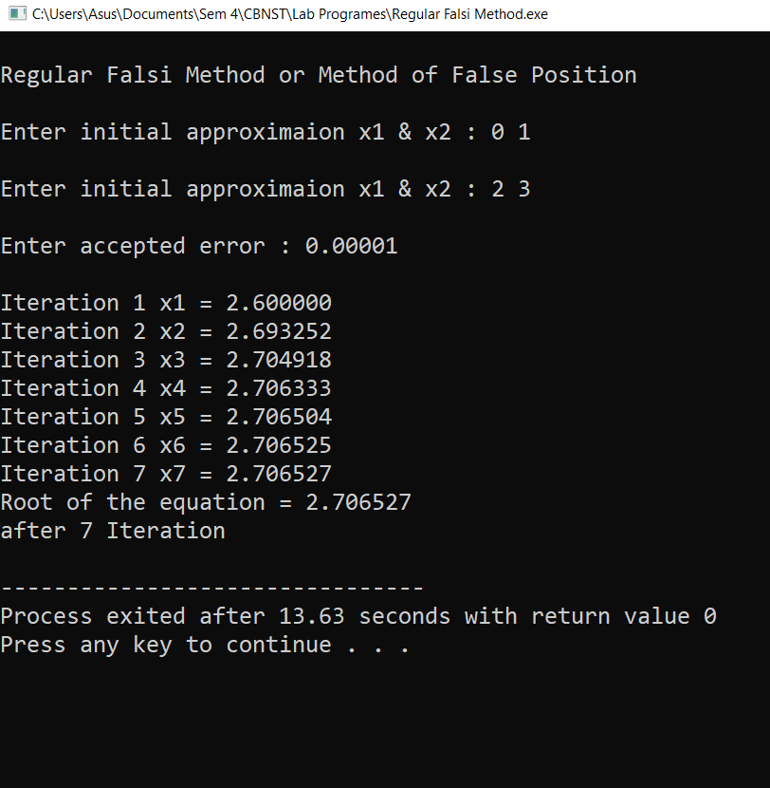
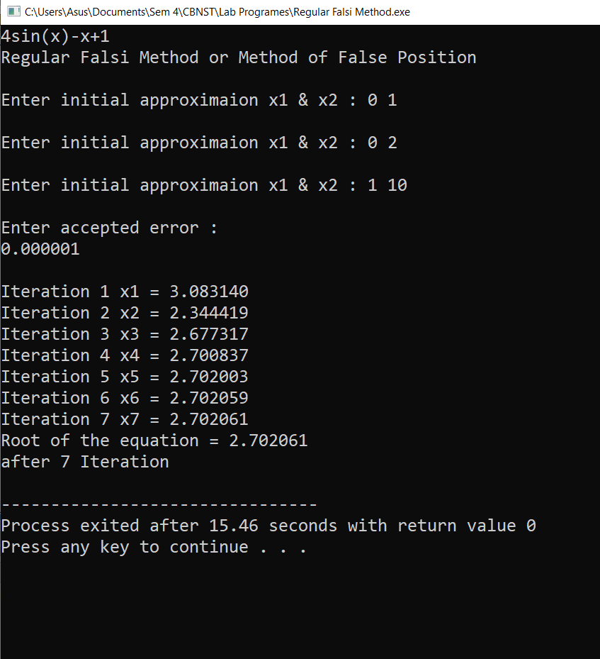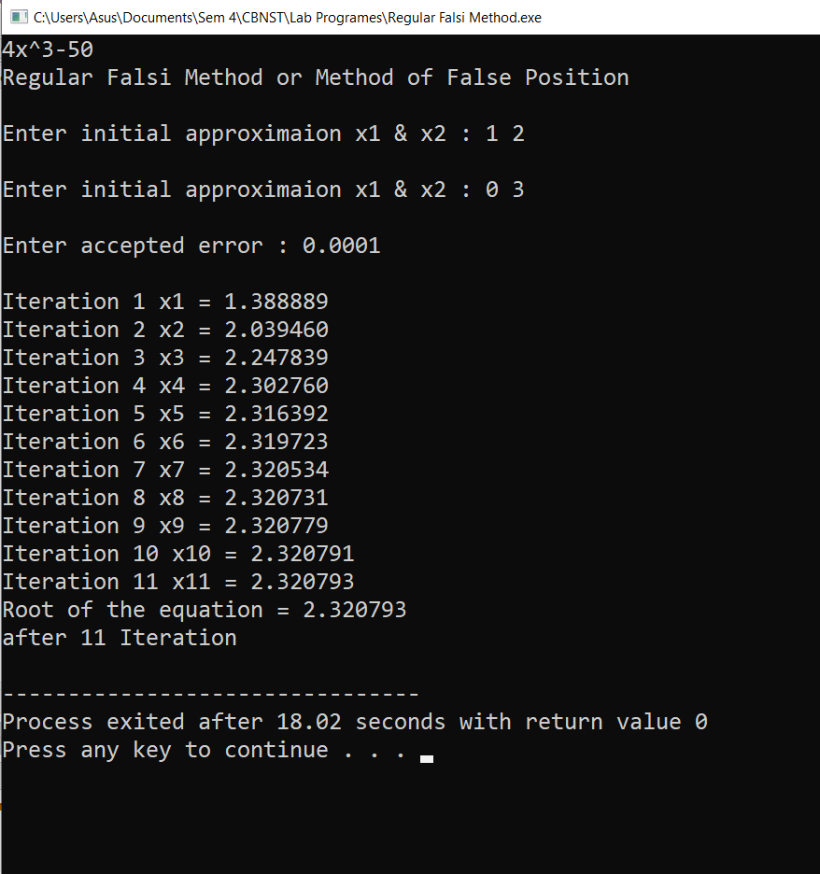

Program 4

Objective: Program to Implement Secant Method
Algorithm:

- Start
- Take 2 initial inputs: x1 & x2
such that f(x1)*f(x2) < 0
- Apply Secant Method to get the value of x
x = x1 - (x2-x1)f(x1)/(f(x2)-f(x1))
- x1=x2
- x2=x
- if f(x)<=error, then print the root of equation
- End
Source Code
/* Secant Method (Method of False Position)
1) Take 2 initial inputs: x1 & x2
such that f(x1)*f(x2) < 0
2) Apply Secant Method to get the value of x
x = x1 - (x2-x1)f(x1)/(f(x2)-f(x1))
3) x1=x2
x2=x
4) if f(x)<=error, then print the root of equation */

#include<stdio.h>
#include<math.h>
#define f(x) (x*x*x+4*x-10)

int main(void)
{
float x1, x2, err;
printf("\nSecant Method\n");
do
{
printf("\nEnter initial approximaion x1 & x2 : ");
scanf("%f%f",&x1,&x2);
}while(f(x1)*f(x2)>=0);
printf("\nEnter accepted error : ");
scanf("%f",&err);

float x;
int count=0;
do
{
count++;
x=x1-(x2-x1)*f(x1)/(f(x2)-f(x1));
x1=x2;
x2=x;
printf("\nIteration %d x%d = %f ",count,count,x);
}while(fabs(f(x))>err);
printf("\nRoot of the equation = %f \nafter %d Iteration \n",x,count);

return 0;
}

Output

Secant Method

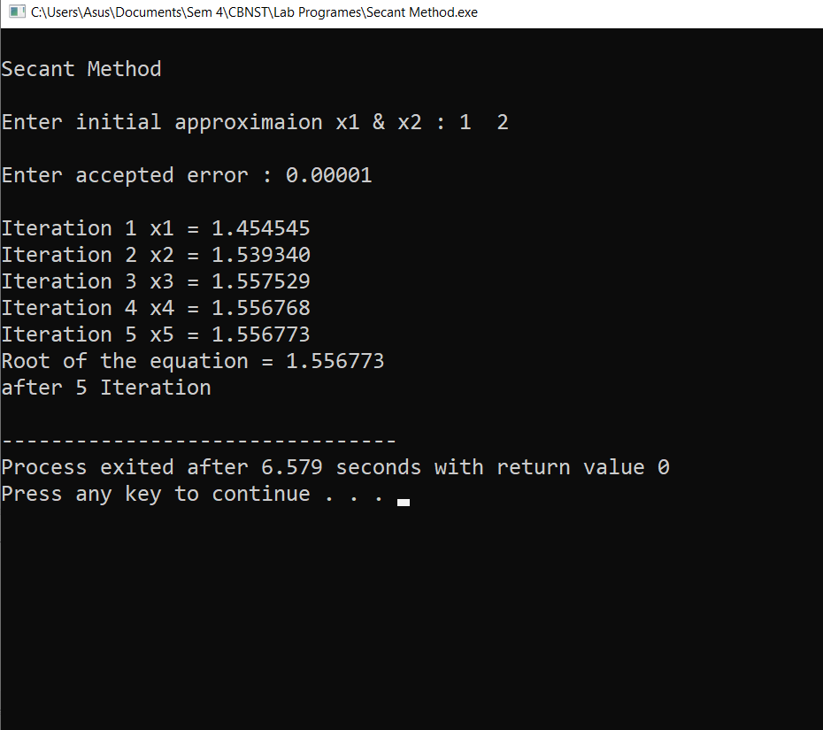
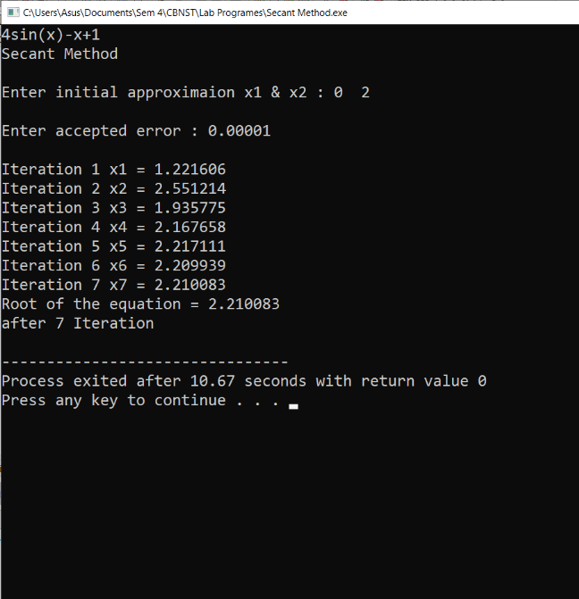
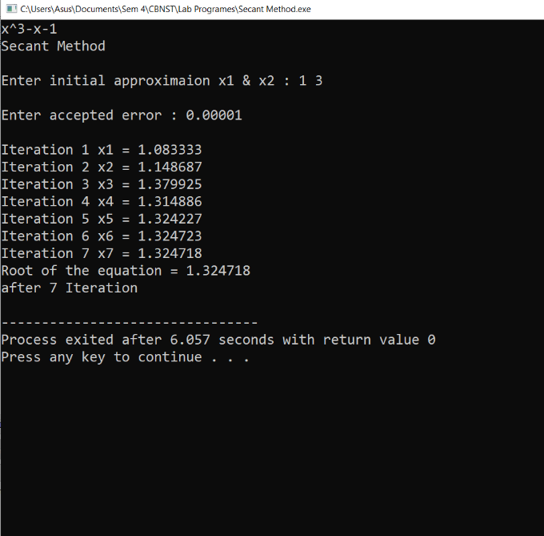
Program 5

Objective: Program to Implement Iteration Method
Algorithm:
- Start
- Read values of x0 and e.
*Here x0 is the initial approximation
e is the absolute error or the desired degree of accuracy, also the stopping criteria*
- Calculate x1 = g(x0)
- If [x1 – x0] <= e, goto step 6.
*Here [ ] refers to the modulus sign*
- Else, assign x0 = x1 and goto step 3.
- Display x1 as the root.
- Stop

Source Code
/* Iterative Method
1) Take 2 initial input : x1 & x2
such that f(x1)*f(x2)<0
2) x = q(x)
3) q`(x)
4) if |q`(x1)|<1 && |q`(x2)|<1
print("function is correct");
5) x0 = is the initial quess at which the function gives smaller value
6) x3 = q(x0)
7) if |x0-x3|<=error then x3 ans
else x0=x3 */

#include<stdio.h>
#include<math.h>
#define f(x) (x*x*x-4*x-9)
#define g(x) (pow((4*x+9),1/3.0))
#define dg(x) (4/3.0*pow((4*x+9),-2/3.0))

int main(void)
{
printf("\nIterative Method\n");
float x1,x2,err;
do
{
printf("\nEnter initial approximation x1 & x2 : ");
scanf("%f%f",&x1,&x2);
}while(f(x1)*f(x2)>=0);
if(fabs(dg(x1))<1&&fabs(dg(x2))<1)
printf("\nFunction is Correct and coverges ");
else
{
printf("\nFunction does not coverges ");
return 1;
}
printf("\nEnter acceptable error : ");
scanf("%f",&err);

float x0,x3;
x3=(x1+x2)/2;
/* OR
if(fabs(f(x1))<fabs(f(x2)))
x3=x1;
else
x3=x2;
*/
int count=0;
do
{
count++;
x0=x3;
x3=g(x0);
printf("\nIteration %d x%d = %f ",count,count,x3);
}while(fabs(x3-x0)>=err);
printf("\nRoot of the equation = %f \nafter %d Iterations \n",x3,count);

return 0;
}

Output

Iterative Method
Or
Successive Approximation Method

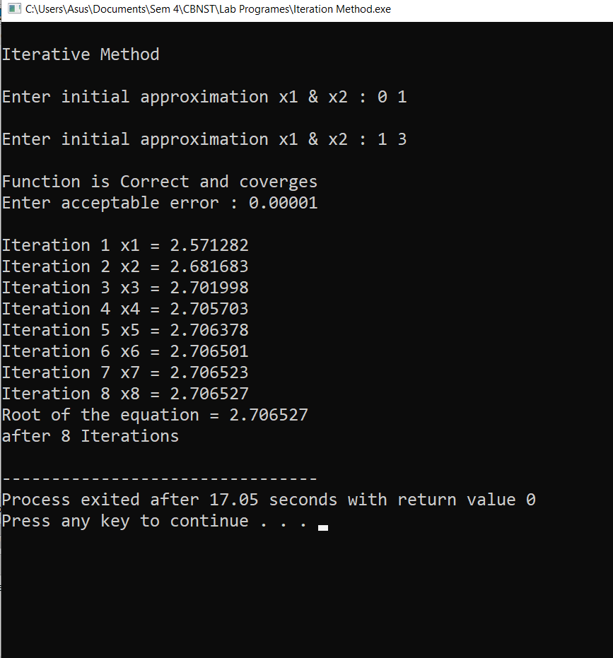
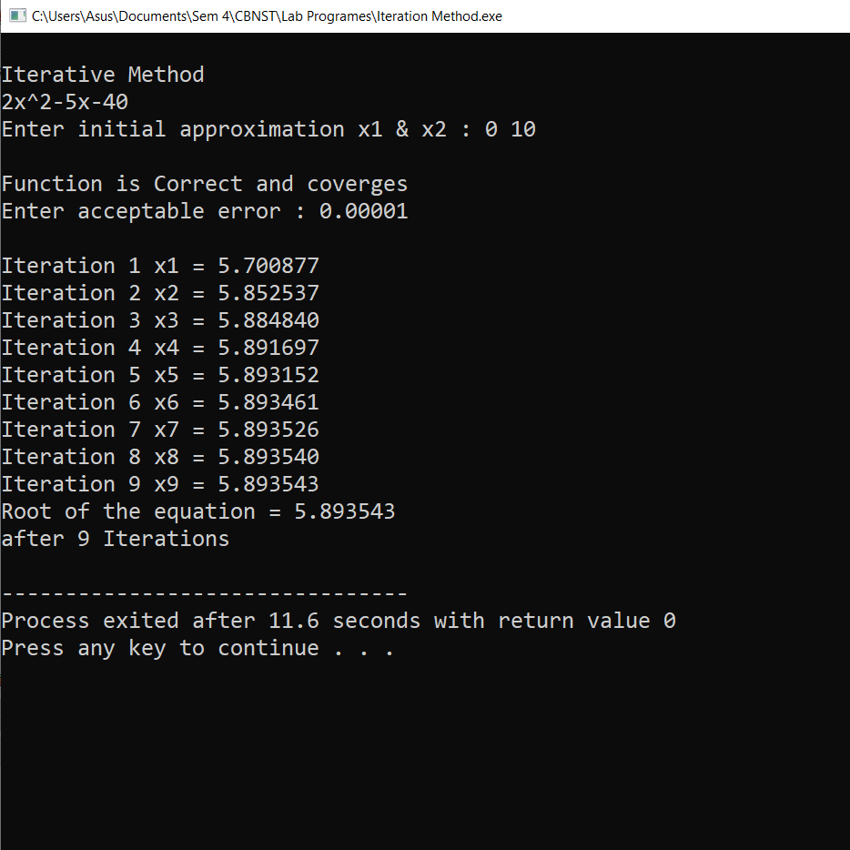
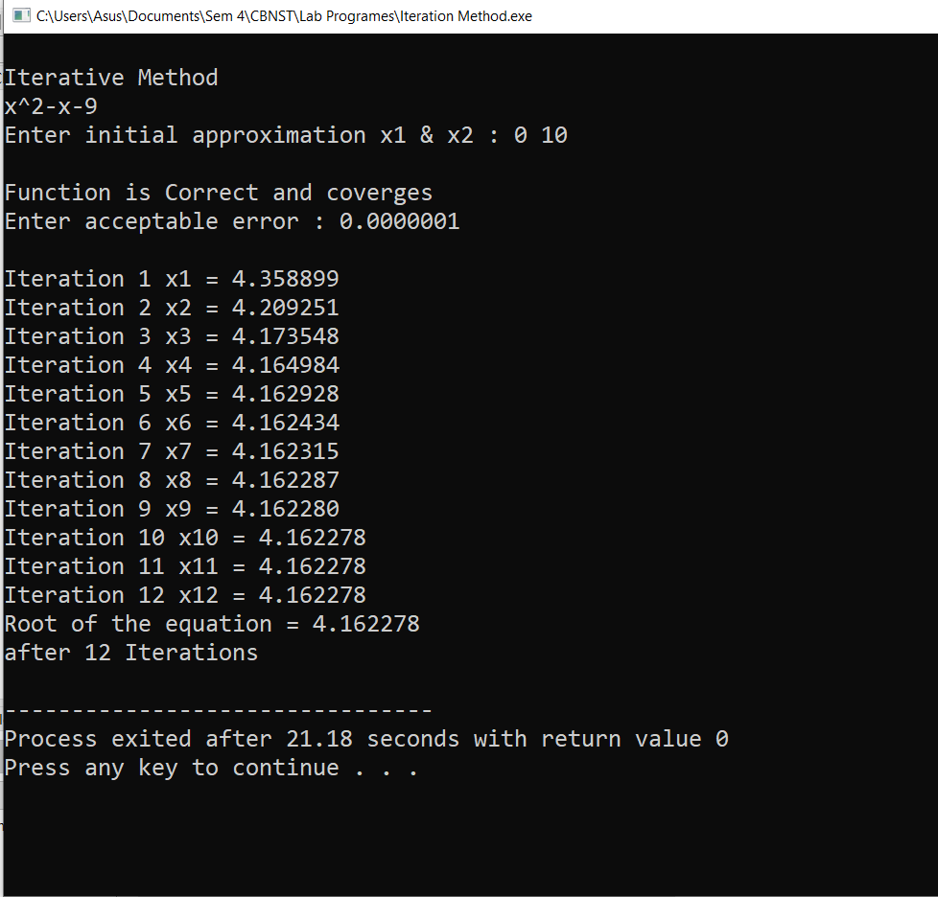
Program 6

Objective: Program to implement Newton Raphson Method.
Algorithm:
- Start
- Read x, e, n, d
*x is the initial guess
e is the absolute error i.e the desired degree of accuracy
n is for operating loop
d is for checking slope*
- Do for i =1 to n in step of 2
- f = f(x)
- f1 = f'(x)
- If ( [f1] < d), then display too small slope and goto 11.
*[ ] is used as modulus sign*
- x1 = x – f/f1
- If ( [(x1 – x)/x1] < e ), the display the root as x1 and goto 11.
*[ ] is used as modulus sign*
- x = x1 and end loop
- Display method does not converge due to oscillation.
- Stop

Source Code
#include<stdio.h>
#include<math.h>

float f(float x)
{
return (x*x-5*x+2);
}
float fd(float x)
{
return (2*x-5);
}
int main(void)
{
float x0, x1, err;
printf("Enter the initial aproximation : ");
scanf("%f",&x1);
printf("Enter the accepted error : ");
scanf("%f",&err);
int count=1;
do
{
x0=x1;
x1=x0-f(x0)/fd(x0);
printf("\n f( %f ) / f'( %f ) = %f / %f = %f \n",x0,x0,f(x0),fd(x0),f(x0)/fd(x0));
printf("%d iteration x%d : %f\n",count,count,x1);
count++;
}while(fabs(x0-x1)>err);
printf("\nAnswer after %d iterations : %f\n",count-1,x1);
return 0;
}
Output
Newton Raphson Method

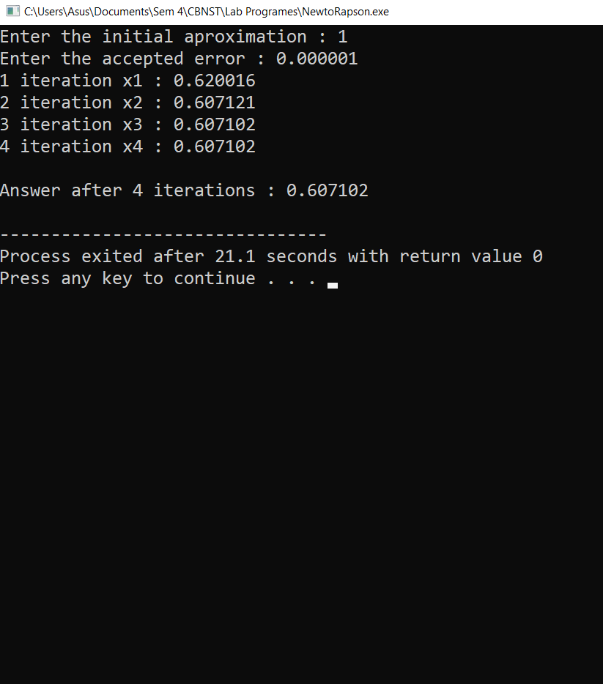
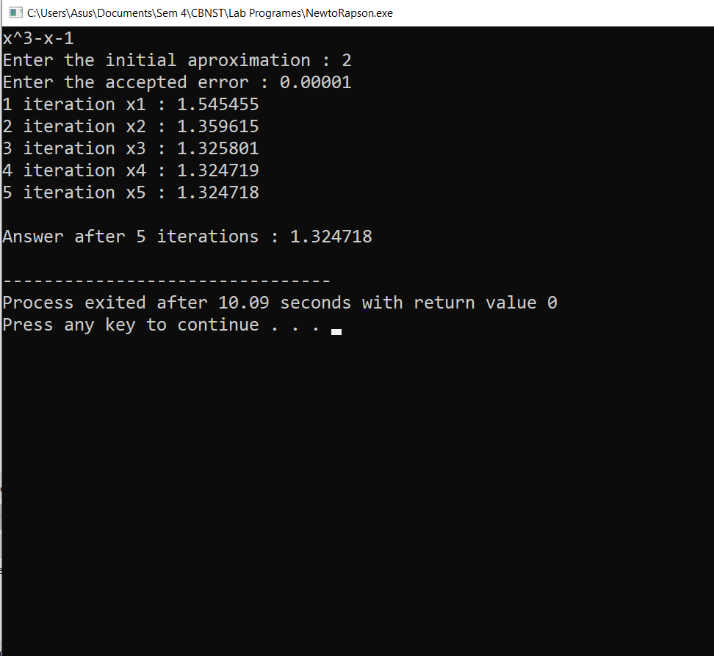
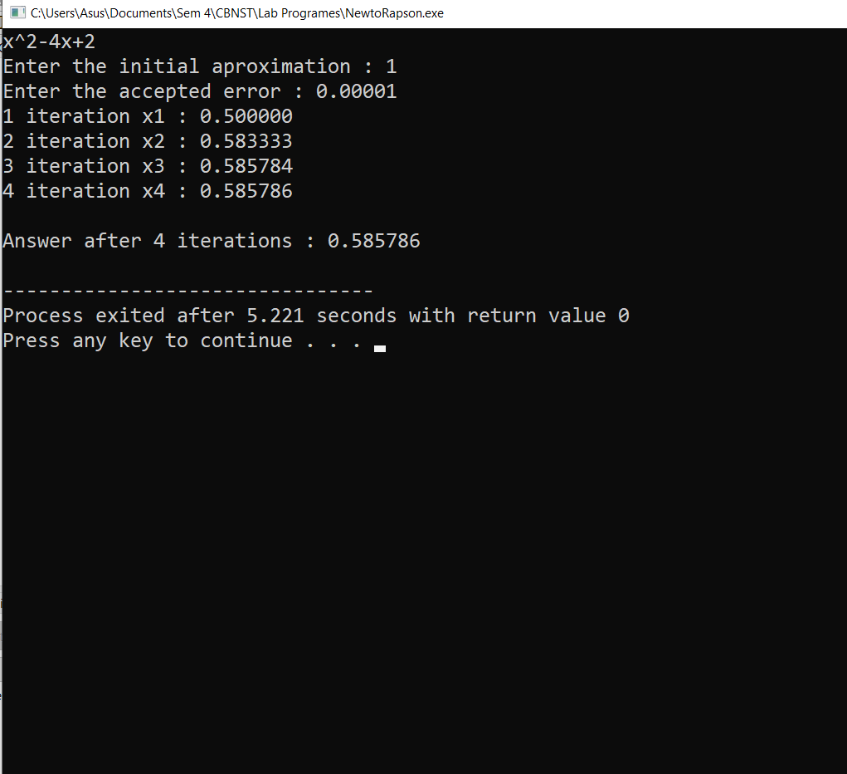
Program 7

Objective: Program to implement Gauss Elimination Method.
Algorithm:
- Start
- Declare the variables and read the order of the matrix n.
- Take the coefficients of the linear equation as:
Do for k=1 to n
Do for j=1 to n+1
Read a[k][j]
End for j
End for k
- Do for k=1 to n-1
Do for i=k+1 to n
Do for j=k+1 to n+1
a[i][j] = a[i][j] – a[i][k] /a[k][k] * a[k][j]
End for j
End for i
End for k
- Compute x[n] = a[n][n+1]/a[n][n]
- Do for k=n-1 to 1
sum = 0
Do for j=k+1 to n
sum = sum + a[k][j] * x[j]
End for j
x[k] = 1/a[k][k] * (a[k][n+1] – sum)
End for k
- Display the result x[k]
- Stop

Source Code
#include<stdio.h>
int main(void)
{
int n, i, j, k, e, l, m;
printf("Enter the number of unknown variables in the equation : ");
scanf("%d",&n);
if(n<=0)
{
if(n==0)
n=-1;
n=n*-1;
}
float A[n][n+1];
printf("Enter the cofficients of the eqation \n");
for(i=0;i<n;i++)
{
for(j=0;j<=n;j++)
scanf("%f",&A[i][j]);
}
printf("\nMatrix\n");
for(i=0;i<n;i++)
{
for(j=0;j<=n;j++)
{
printf("%.4f\t\t",A[i][j]);
}
printf("\n");
}
float r;
for(i=0;i<n-1;i++)
{
for(j=i+1;j<n;j++)
{
if(A[i][i]==0)
{
for(e=0;e<n;e++)
{
if(A[e][i]!=0)
{
for(k=0;k<=n;k++)
A[i][k]+=A[e][k];
break;
}
}
}
r=A[j][i]/A[i][i];
for(k=0;k<=n;k++)
A[j][k]=A[j][k]-r*A[i][k];
}
printf("\nMatrix in %d\n",i);
for(l=0;l<n;l++)
{
for(m=0;m<=n;m++)
{
printf("%.4f\t\t",A[l][m]);
}
printf("\n");
}
}
printf("\nUpper Triangular Matrix\n");
for(i=0;i<n;i++)
{
for(j=0;j<=n;j++)
{
printf("%.4f\t\t",A[i][j]);
}
printf("\n");
}
float sum;
float x[n];
for(i=n-1;i>=0;i--)
{
sum=A[i][n];
for(j=i;j<n;j++)
sum=sum-A[i][j]*x[j];
x[i]=sum/A[i][i];
}

printf("\nSollution\n");
for(i=0;i<n;i++)
printf("\nX%d = %.4f",i+1,x[i]);
return 0;
}

Output
Gauss Elimination Method

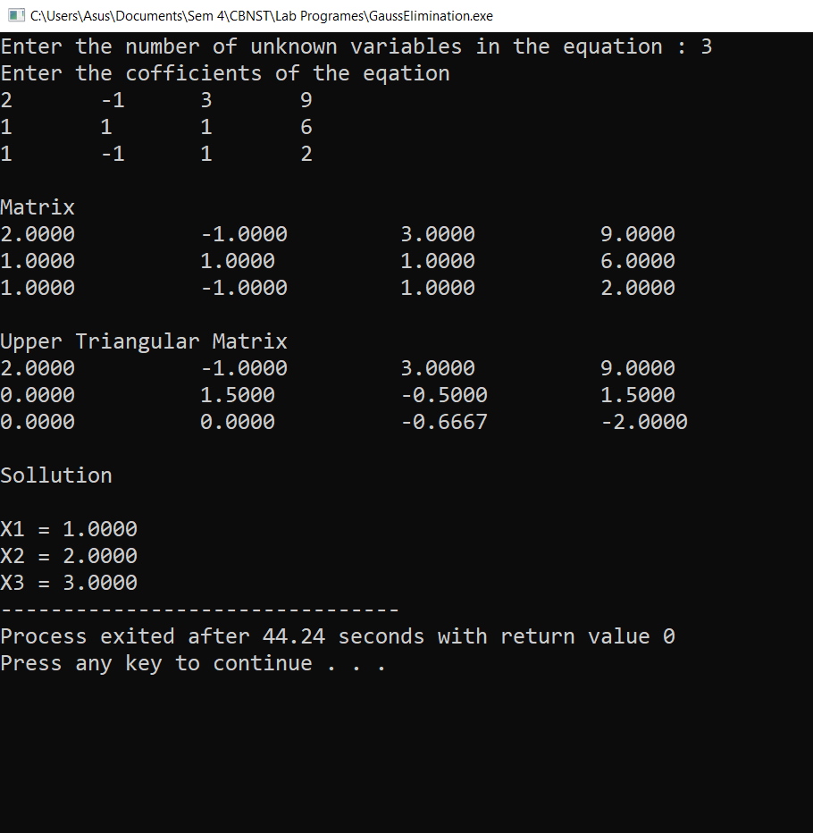
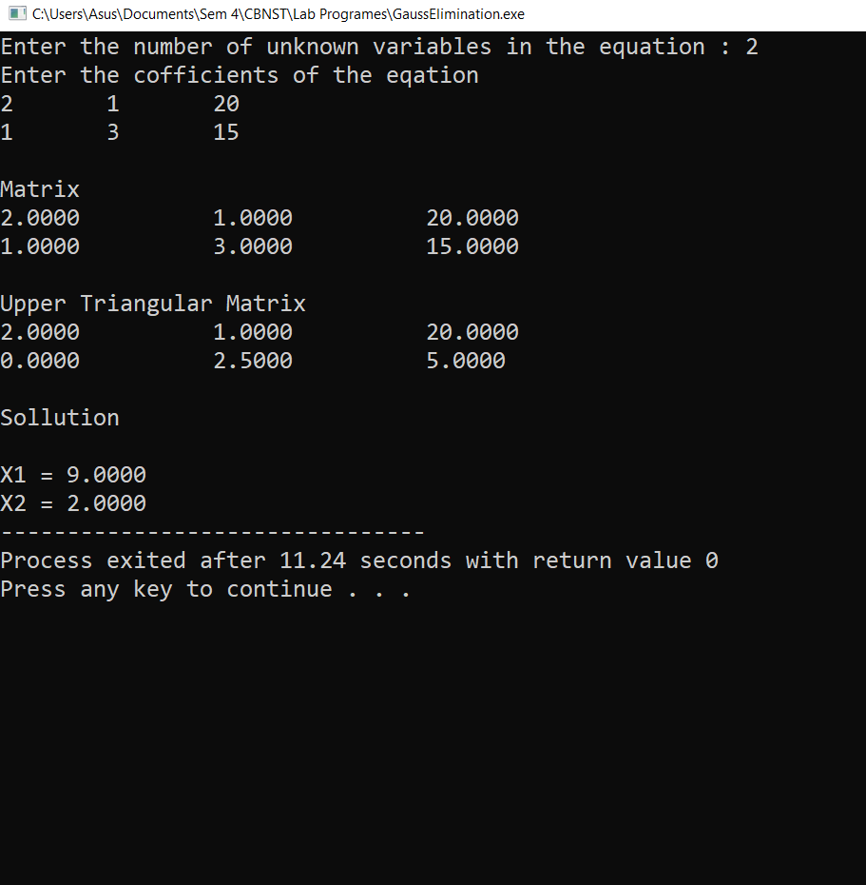
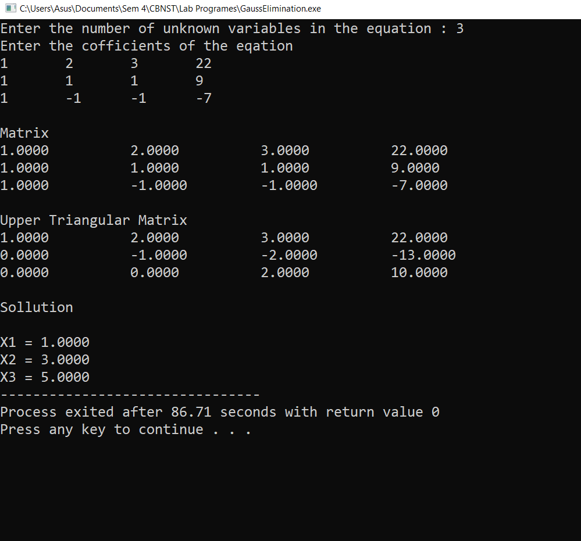
Program 8

Objective: Program to implement Gauss Jordan Method.
Algorithm:
- Start
- Read the order of the matrix ‘n’ and read the coefficients of the linear equations.
- Do for k=1 to n
Do for l=k+1 to n+1
a[k][l] = a[k][l] / a[k][k]
End for l
Set a[k][k] = 1
Do for i=1 to n
if (i not equal to k) then,
Do for j=k+1 to n+1
a[i][j] = a[i][j] – (a[k][j] * a[i][k])
End for j
End for i
End for k
- Do for m=1 to n
x[m] = a[m][n+1]
Display x[m]
End for m
- Stop

Source Code
#include<stdio.h>

int main(void)
{
int n, i, j, k, e, l, m;
printf("Enter the number of unknown variables in the equation : ");
scanf("%d",&n);
if(n<=0)
{
if(n==0)
n=-1;
n=n*-1;
}
float A[n][n+1];
printf("Enter the cofficients of the eqation \n");
for(i=0;i<n;i++)
{
for(j=0;j<=n;j++)
scanf("%f",&A[i][j]);
}
printf("\nMatrix\n");
for(i=0;i<n;i++)
{
for(j=0;j<=n;j++)
{
printf("%.4f\t\t",A[i][j]);
}
printf("\n");
}
float r;
for(i=0;i<n;i++)
{
for(j=0;j<n;j++)
{
if(j==i)
continue;
if(A[i][i]==0)
{
for(e=0;e<n;e++)
{
if(A[e][i]!=0)
{
for(k=0;k<=n;k++)
A[i][k]+=A[e][k];
}
}
}
r=A[j][i]/A[i][i];
for(k=0;k<=n;k++)
A[j][k]=A[j][k]-r*A[i][k];
}
printf("\nMatrix in %d\n",i);
for(l=0;l<n;l++)
{
for(m=0;m<=n;m++)
{
printf("%.4f\t\t",A[l][m]);
}
printf("\n");
}
}
printf("\nDiagnoal Matrix\n");
for(i=0;i<n;i++)
{
for(j=0;j<=n;j++)
{
printf("%.4f\t\t",A[i][j]);
}
printf("\n");
}
float sum;
float x[n];
for(i=0;i<n;i++)
{
x[i]=A[i][n]/A[i][i];
}

printf("\nSollution\n");
for(i=0;i<n;i++)
printf("\nX%d = %.4f",i+1,x[i]);
return 0;
}

Output
Gauss Jordan Method

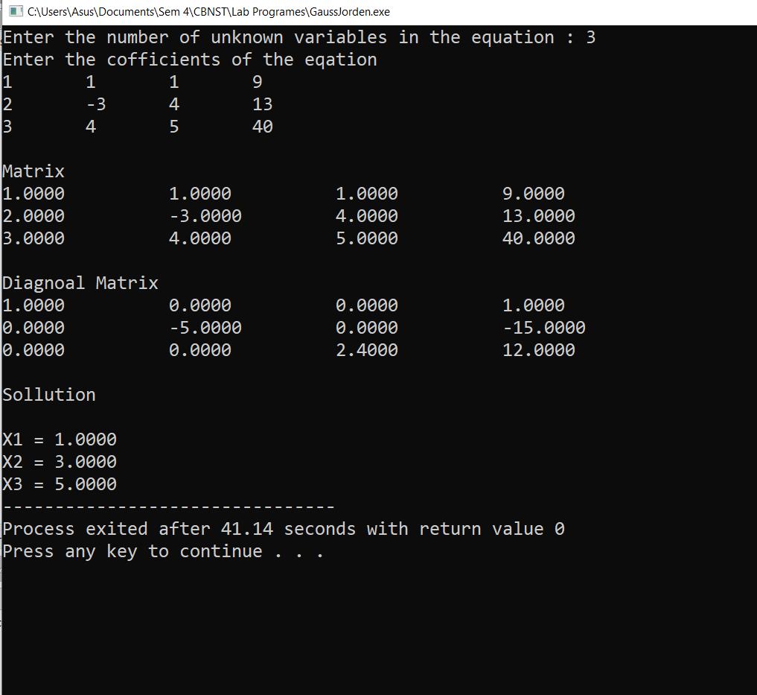
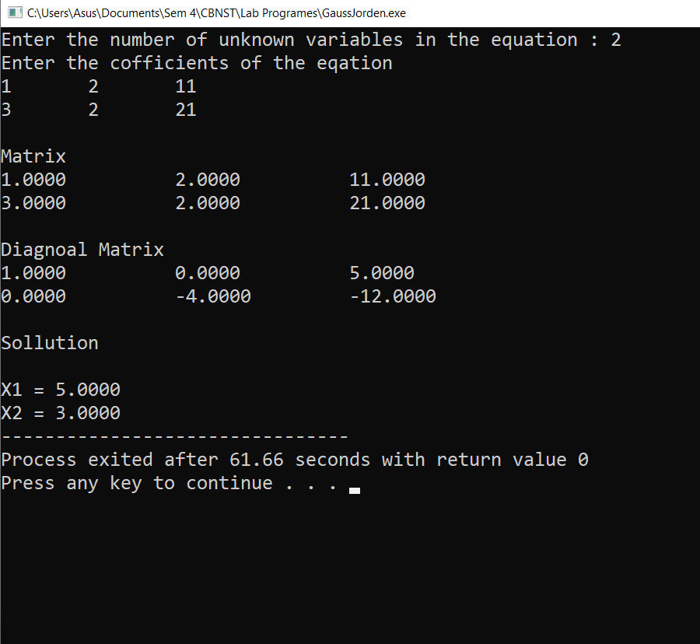
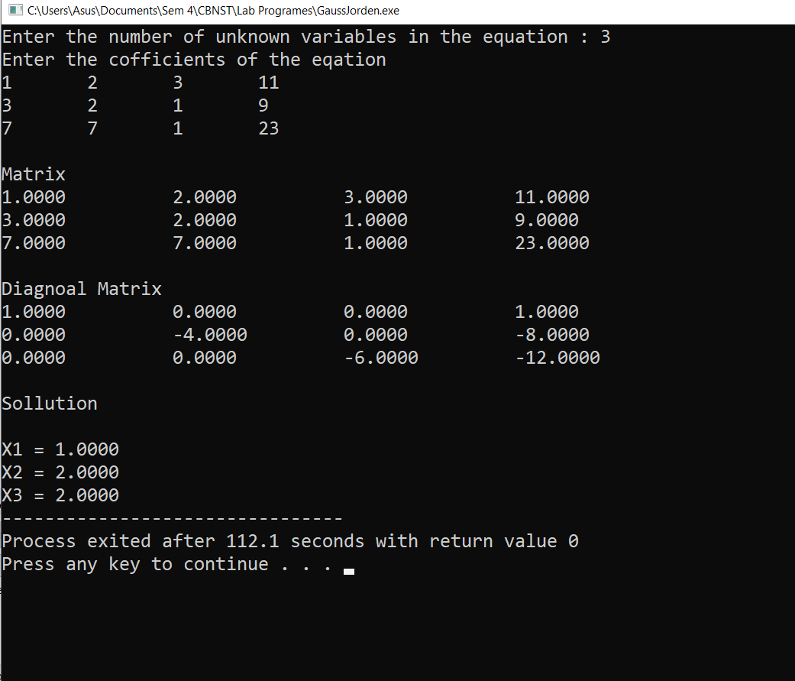
Program 9

Objective: Program to implement Gauss Jacobi Method.
Algorithm:
- Start
- Arrange the given system of linear equation in diagonally dominant form
- Read tolerance error
- Convert the first equation in terms of first variable,and second equation in term of second variable and so on
- Set initial guess for x0,y0,z0
- Substitue value of x0,y0,z0,--------from step 5 in equation obtained on step 4 to calculate new values
- X1,y1,z1----------
- If /x0-x1/ > e and /y0-y1/ >e and so on ,then goto step 9
- Set x0=x1,y0=y1,z0=z1, and so on goto step 6
- Print value of x1,y1,z1 and so on
- Stop

Source Code
/* Gauss Jacobi Iterative Method */
#include<stdio.h>
#include<math.h>
#define f1(y,z) (17-y+2*z)/20
#define f2(x,z) (-18-3*x+z)/20
#define f3(x,y) (25-2*x+3*y)/20
int main(void)
{
float x0,y0,z0,x1,y1,z1;
x0=y0=z0=0.00;
float err,e1,e2,e3;
int count=1;
printf("Enter allowed Error : ");
scanf("%f",&err);
printf("Enter Inital apportimation \n");
scanf("%f%f%f",&x0,&y0,&z0);
do
{
x1=f1(y0,z0);
y1=f2(x0,z0);
z1=f3(x0,y0);
printf("Iteration %d x%d=%f y%d=%f z%d=%f \n",count,count,x1,count,y1,count,z1);
e1=fabs(x1-x0);
e2=fabs(y1-y0);
e3=fabs(z1-z0);
x0=x1;
y0=y1;
z0=z1;
count++;
}while(e1>err||e2>err||e3>err);
printf("Result after %dth iteration \nx=%f y=%f z=%f \n",count-1,x1,y1,z1);
return 0;
}
/* OUTPUT
Enter allowed Error : 0.000001
Enter Inital apportimation
0 0 0
Iteration 1 x1=0.850000 y1=-0.900000 z1=1.250000
Iteration 2 x2=1.020000 y2=-0.965000 z2=1.030000
Iteration 3 x3=1.001250 y3=-1.001500 z3=1.003250
Iteration 4 x4=1.000400 y4=-1.000025 z4=0.999650
Iteration 5 x5=0.999966 y5=-1.000077 z5=0.999956
Iteration 6 x6=1.000000 y6=-0.999997 z6=0.999992
Iteration 7 x7=0.999999 y7=-1.000000 z7=1.000000
Iteration 8 x8=1.000000 y8=-1.000000 z8=1.000000
Iteration 9 x9=1.000000 y9=-1.000000 z9=1.000000
Result after 9th iteration
x=1.000000 y=-1.000000 z=1.000000
*/

Output
Gauss Jacobi
Iterative Method

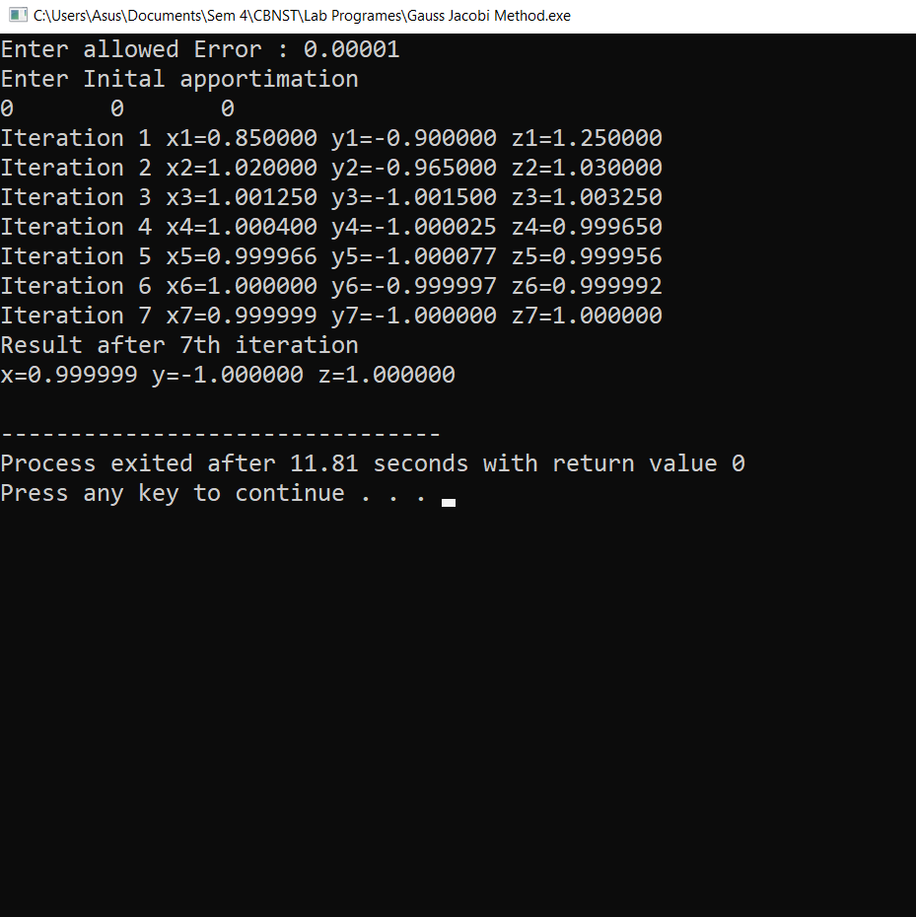
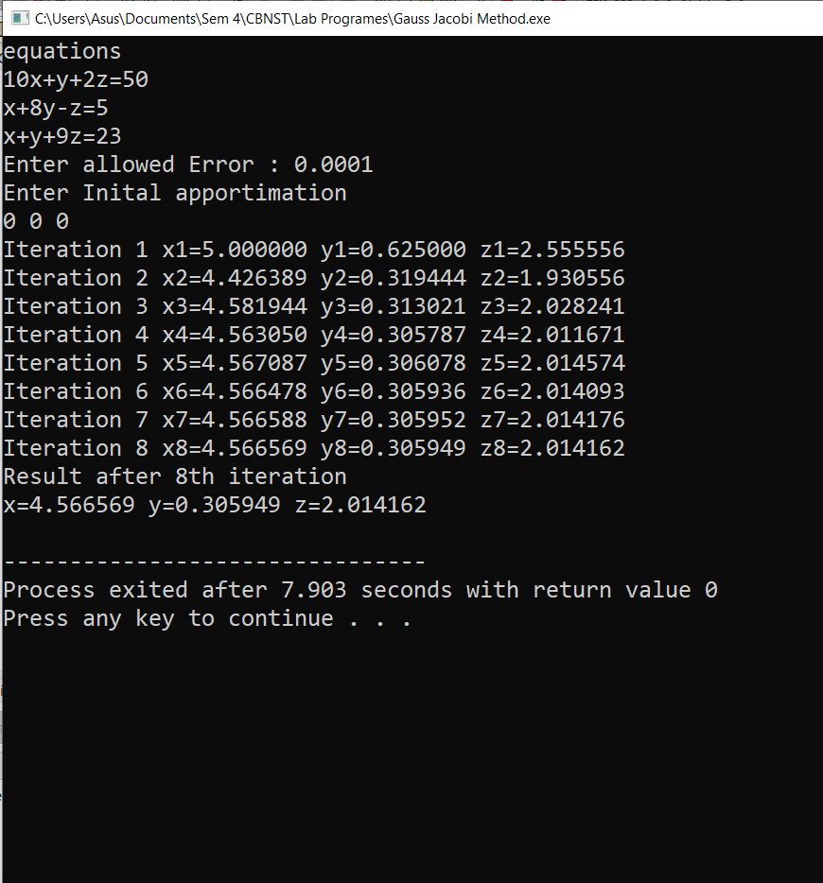
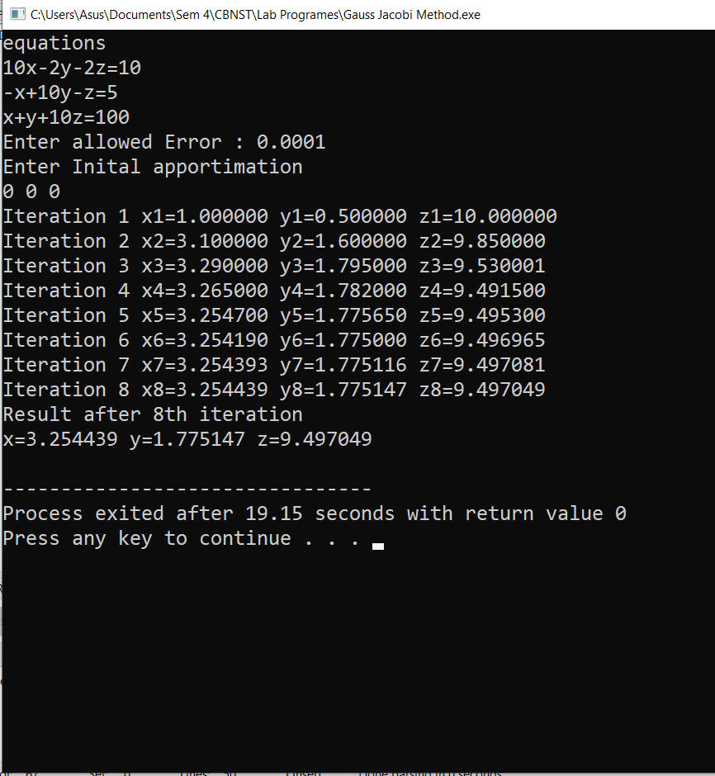
Program 10

Objective: Program to implement Gauss Seidel Method.
Algorithm:
- Start
- Declare the variables and read the order of the matrix n
- Read the stopping criteria er
- Read the coefficients aim as
Do for i=1 to n
Do for j=1 to n
Read a[i][j]
Repeat for j
Repeat for i
- Read the coefficients b[i] for i=1 to n
- Initialize x0[i] = 0 for i=1 to n
- Set key=0
- For i=1 to n
Set sum = b[i]
For j=1 to n
If (j not equal to i)
Set sum = sum – a[i][j] * x0[j]
Repeat j
x[i] = sum/a[i][i]
If absolute value of ((x[i] – x0[i]) / x[i]) >er, then
Set key = 1
Set x0[i] = x[i]
Repeat i
- If key = 1, then
Goto step 6
Otherwise print results

Source Code
/* Gauss Seidel Iterative Method */
#include<stdio.h>
#include<math.h>
#define f1(y,z) (3+y+z)/4
#define f2(x,z) (9+2*x-z)/6
#define f3(x,y) (-6+x-y)/7
int main(void)
{
float x0,y0,z0,x1,y1,z1;
x0=y0=z0=0.00;
float err,e1,e2,e3;
int count=1;
printf("Enter allowed Error : ");
scanf("%f",&err);
printf("Enter Inital apportimation \n");
scanf("%f%f%f",&x0,&y0,&z0);
do
{
x1=f1(y0,z0);
y1=f2(x1,z0);
z1=f3(x1,y1);
printf("Iteration %d x%d=%f y%d=%f z%d=%f \n",count,count,x1,count,y1,count,z1);
e1=fabs(x1-x0);
e2=fabs(y1-y0);
e3=fabs(z1-z0);
x0=x1;
y0=y1;
z0=z1;
count++;
}while(e1>err||e2>err||e3>err);
printf("Result after %dth iteration \nx=%f y=%f z=%f \n",count-1,x1,y1,z1);
return 0;
}

Output
Gauss Seidel
Iterative Method

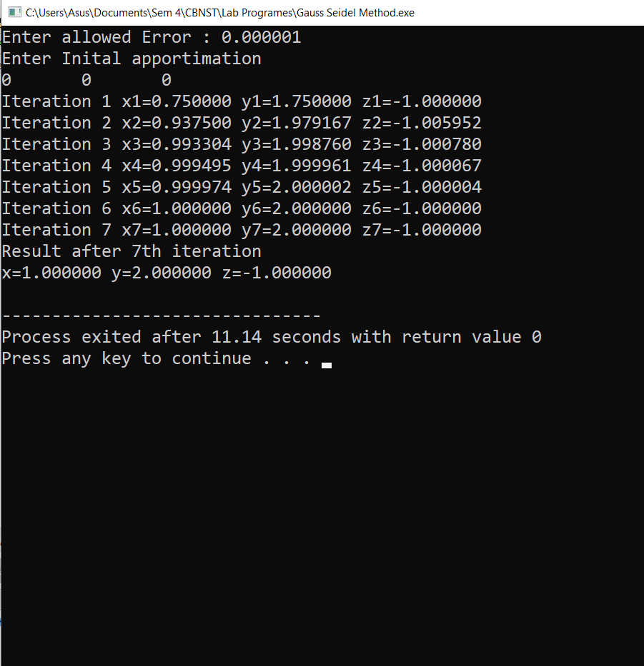
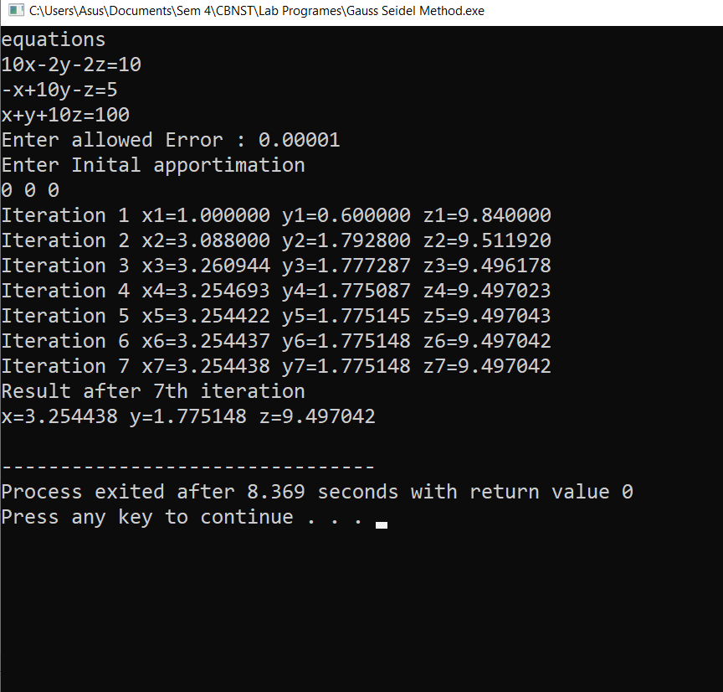
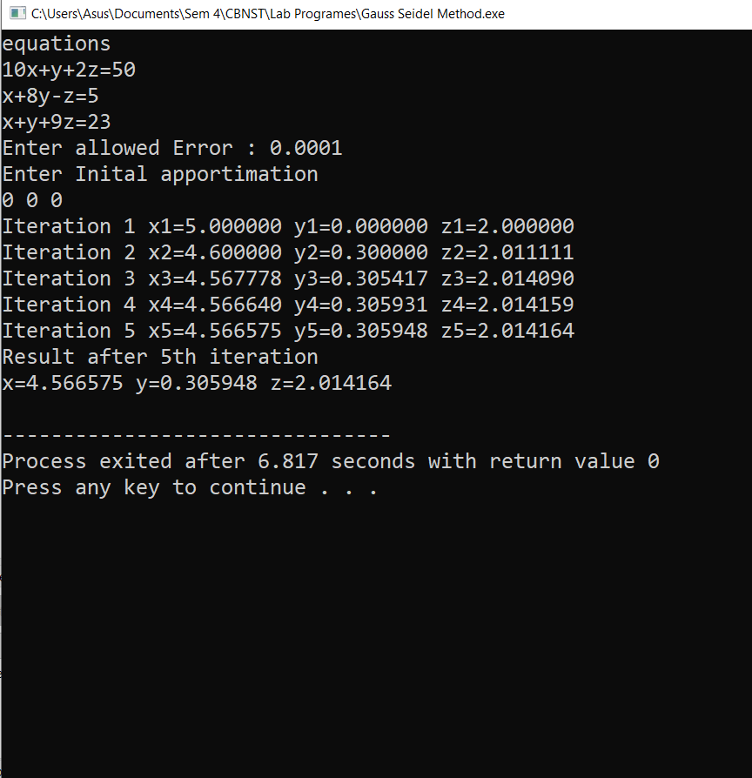

Program 11

Objective: Program to implement Newton Forward Interpolation Method.
Algorithm:
- Start of the program

- Input number of terms n

- Input the array ax

- Input the array ay

- h=ax[1] – ax[0]

- for i=0; i<n-1; i++

- diff[i] [1]=ay[i + 1] – ay[i]

- End Loop i

- for j=2; j<=4; j++

- for i = 0; i<n – j; i++

- diff[i][j]=diff [i + 1] [j – 1]-diff [i][j – 1]

- End Loop i

- End Loop j

- i=0

- Repeat Step 16 until ax[i]<x

- i=i + 1

- i=i – 1;

- p=(x – ax [i])/h

- y1=p*diff[i – 1][1]

- y2=p*(p+1)*diff [i – 1][2]/2

- y3=(p+1)*p*(p-1)*diff[i –2 ][3]/6

- y4=(p+2)*(p+1)*p*(p – 1)*diff[i – 3][4]/24

- y=ay[i]+y1+y2+y3+y4

- Print output x, y

- End of program.

Source Code
#include<stdio.h>
int main()
{
printf("Enter the total no of observations\n");
int n, i, j;
scanf("%d",&n);
if (n<=0)
{
if(n==0)
n=-1;
n*=-1;
}
printf("Enter the data in tabular form\nx\t\ty \n");
float x[n], y[n][n], f;
for(i=0;i<n;i++)
scanf("%f%f",&x[i],&y[i][0]);
printf("\nData inputed by the user\nx\t\ty\n");
for(i=0;i<n;i++)
printf("%f\t%f\n",x[i],y[i][0]);
printf("\nEnter the value of x to find the value of y at that instance :\n");
double u, u1 , h, a;
scanf("%f",&f);
h=x[1]-x[0];
u=(f-x[0])/h;
u1=u;
a=y[0][0];
long fact=1;
for(j=1;j<n;j++)
{
for(i=0;i<=(n-j);i++)
y[i][j]=y[i+1][j-1]-y[i][j-1];
}
printf("\nForward Difference table\nx\t\ty");
for(i=1;i<n;i++)
{
printf("\t\ty%d",i);
}
for(i=0;i<n;i++)
{
printf("\n%f",x[i]);
for(j=0;j<(n-i);j++)
printf("\t%f",y[i][j]);
}

for(j=1;j<n;j++)
{
a=a+(u1*y[0][j])/fact;
u1*=(u-j);
fact*=j+1;
}
printf("\nBy Newton Forward Substitution \nfor x = %f\t y = %lf \n",f,a);
return 0;
}

Output
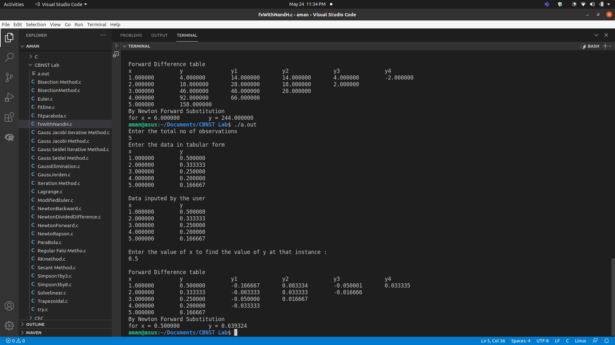

Program 12

Objective: Program to implement Newton Backward Interpolation Method.
Algorithm:
- Start of the program.

- Input number of terms n

- Input the array ax

- Input the array ay

- h=ax[1]-ax[0]

- for i=0; i<n–1; i++

- diff[i][1]=ay[i+1]–ay[i]

- End Loop i

- for j = 2; j < = 4; j + +

- for i=0; i<n–j; i++

- diff[i][j]=diff[i+1][j–1]–diff [i][j–1]

- End Loop i

- End Loop j

- i=0

- Repeat Step 16 until (!ax[i]<x)

- x0=mx[i]

- sum=0

- y0=my[i]

- fun=1

- p=(x–x0)/h

- sum=y0

- k=1; k<=4; k++

- fun=(fun*(p–(k–1)))/k

- sum=sum+fun*diff[i][k]

- End loop k

- Print Output x,sum

- End of Program

Source Code
#include<stdio.h>
int main()
{
printf("Enter the total no of observations\n");
int n, i, j;
scanf("%d",&n);
if (n<=0)
{
if(n==0)
n=-1;
n*=-1;
}
printf("Enter the data in tabular form\nx\t\ty \n");
float x[n], y[n][n], f;
for(i=0;i<n;i++)
scanf("%f%f",&x[i],&y[i][0]);
printf("\nData inputed by the user\nx\t\ty\n");
for(i=0;i<n;i++)
printf("%f\t%f\n",x[i],y[i][0]);
printf("\nEnter the value of x to find the value of y at that instance :\n");
double u, u1 , h, a;
scanf("%f",&f);
h=x[1]-x[0];
u=(f-x[n-1])/h;
u1=u;
a=y[n-1][0];
long fact=1;
for(j=1;j<n;j++)
{
for(i=0;i<=(n-j);i++)
y[i][j]=y[i+1][j-1]-y[i][j-1];
}
printf("\nBackward Difference table\nx\t\ty");
for(i=1;i<n;i++)
{
printf("\t\ty%d",i);
}
for(i=0;i<n;i++)
{
printf("\n%f",x[i]);
for(j=0;j<(n-i);j++)
printf("\t%f",y[i][j]);
}

for(j=1;j<n;j++)
{
a=a+(u1*y[n-j-1][j])/fact;
u1*=(u+j);
fact*=j+1;
}
printf("\n\nBy Newton Backward Substitution \nfor x = %f\t y = %lf \n",f,a);
return 0;
}

Output

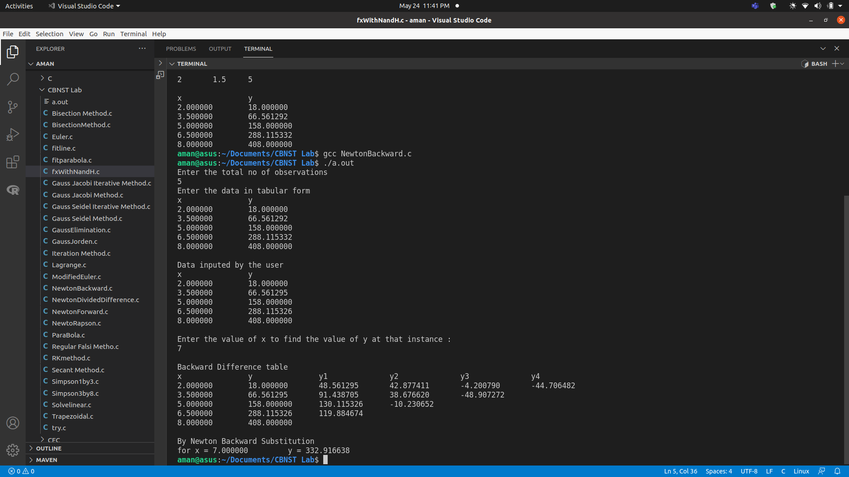

Program 13

Objective: Program to implement Lagrange’s Interpolation Method.
Algorithm:

1.Start
2. Read number of data (n)
3. Read data Xi and Yi for i=1 ton n
4. Read value of independent variables say xp
whose corresponding value of dependent say yp is to be determined.
5. Initialize: yp = 0

6. For i = 1 to n
Set p = 1
For j =1 to n
If i ≠ j then
Calculate p = p * (xp - Xj)/(Xi - Xj)
End If
Next j
Calculate yp = yp + p * Yi
Next i

7. Display value of yp as interpolated value.
8.Stop

Source Code
#include<stdio.h>
int main()
{
printf("Enter the total no of observations\n");
int n, i, j;
scanf("%d",&n);
if (n<=0)
{
if(n==0)
n=-1;
n*=-1;
}
printf("Enter the data in tabular form\nx\t\ty \n");
float x[n], y[n], X;
double fy=0, pro, div;
for(i=0;i<n;i++)
scanf("%f%f",&x[i],&y[i]);
printf("\nData inputed by the user\nx\t\ty\n");
for(i=0;i<n;i++)
printf("%f\t%f\n",x[i],y[i]);
printf("\nEnter the value of x to find the value of y at that instance :\n");
scanf("%f",&X);
for(i=0;i<n;i++) {
pro=div=1;
if(X==x[i]) {
printf("X in table f(%f) = %f\n",X,y[i]);
return 1;
}
for(j=0;j<n;j++) {
if(i==j)
continue;
pro*=(X-x[j])/(x[i]-x[j]);
div*=x[i]-x[j];
}
pro*=y[i];
printf("\t(%d) %lf [/] %lf\n",i,pro,div);
fy+=pro;
}
printf("\n f(%f) = %lf\n",X,fy);
return 0;
}

Output
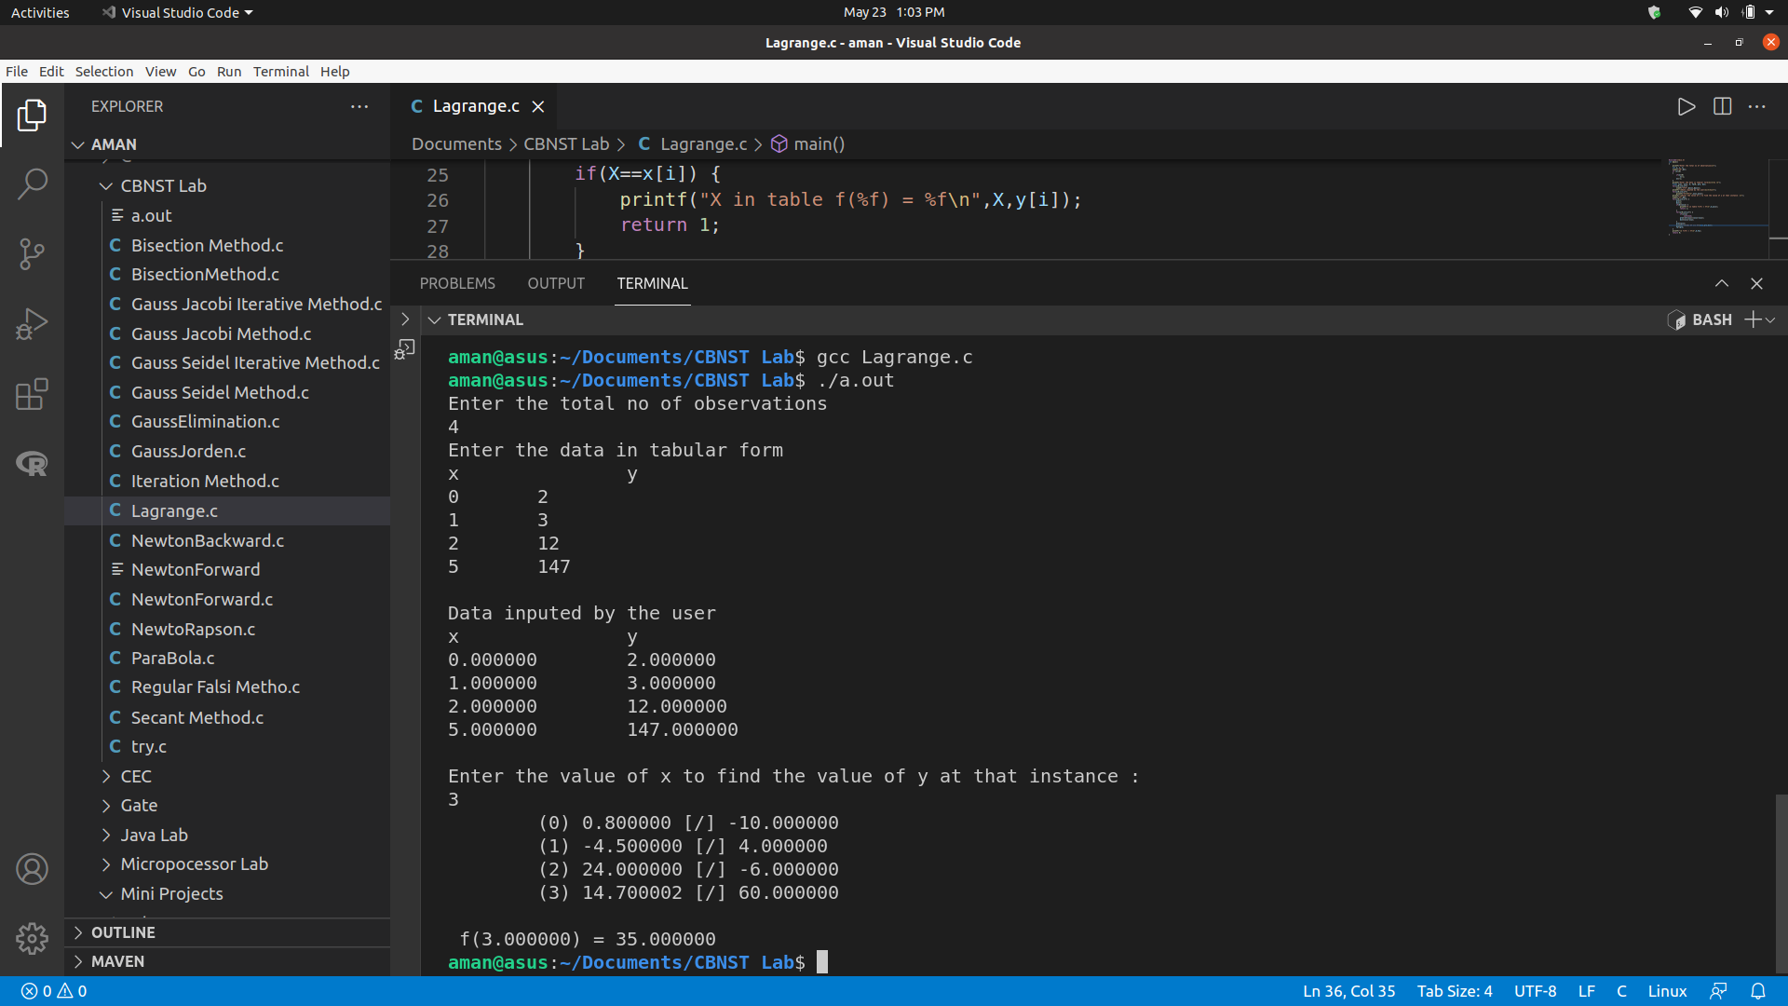

Program 14

Objective: Program to implement Trapezoidal rule.
Algorithm:

- Start
- Input interval n
- Input the table of x, y
- Apply formula and print the result

∫ydx=h/2(y0+2(y1+y2+y3+...+yn-1)+yn)

- End

Source Code
#include<stdio.h>

int main(void) {
printf("Enter the total no of observations\n");
int n, i, j;
scanf("%d",&n);
if (n<=0)
{
if(n==0)
n=-1;
n*=-1;
}
printf("Enter the data in tabular form\nx\t\ty \n");
double x[n], y[n], X;
for(i=0;i<n;i++)
scanf("%lf%lf",&x[i],&y[i]);
printf("\nData inputed by the user\nx\t\ty\n");
for(i=0;i<n;i++)
printf("%lf\t%lf\n",x[i],y[i]);
X=y[0]+y[n-1];
for(i=1;i<n-1;i++)
X+=2*y[i];
double h=x[1]-x[0];
printf("\nX is %lf\n",X);
X=X*h/2;
printf("\nNumerical Integration Using Trapezoidal Rule \n%lf\n",X);
return 0;
}

Output
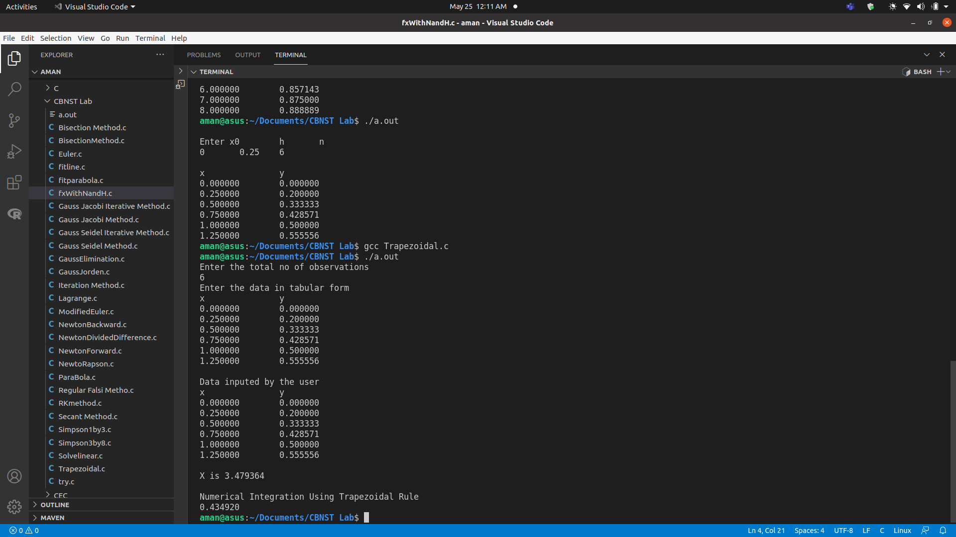

Program 15

Objective: Program to implement Simpson 1/3 rule.
Algorithm:

Step 1. Start;
Step 2. Input function f(x);
Step 3. Read a,b,n; // the lower and upper limits and number of sub-intervals
Step 4. Compute h=(b-a)/n;
Step 5. Sum = [f(a)-f(a+nh)];
Step 6. For i=1 to n-1 step 2 do
Compute sum = sum + 4*f(a+ih)+2*f(a+(i+1)h);
endfor;
Step 7. Compute result = sum * h/3;
Step 8. Print result;
Step 9. Stop;

Source Code
#include<stdio.h>

int main(void) {
printf("Enter the total no of observations\n");
int n, i, j;
scanf("%d",&n);
if (n<=0)
{
if(n==0)
n=-1;
n*=-1;
}
printf("Enter the data in tabular form\nx\t\ty \n");
double x[n], y[n], X, sumodd=0, sumeven=0;
for(i=0;i<n;i++)
scanf("%lf%lf",&x[i],&y[i]);
printf("\nData inputed by the user\nx\t\ty\n");
for(i=0;i<n;i++)
printf("%lf\t%lf\n",x[i],y[i]);
X=y[0]+y[n-1];
for(i=1;i<n-1;i++) {
if(i%2==0)
sumeven+=y[i];
else
sumodd+=y[i];
}
double h=x[1]-x[0];
printf("\nsum odd is %lf\nsum even is %lf\n",sumodd,sumeven);
X=(y[0]+y[n-1]+4*sumodd+2*sumeven)*h/3;
printf("\nNumerical Integration Using Simpsons 1/3 Rule \n%lf\n",X);
return 0;
}

Output

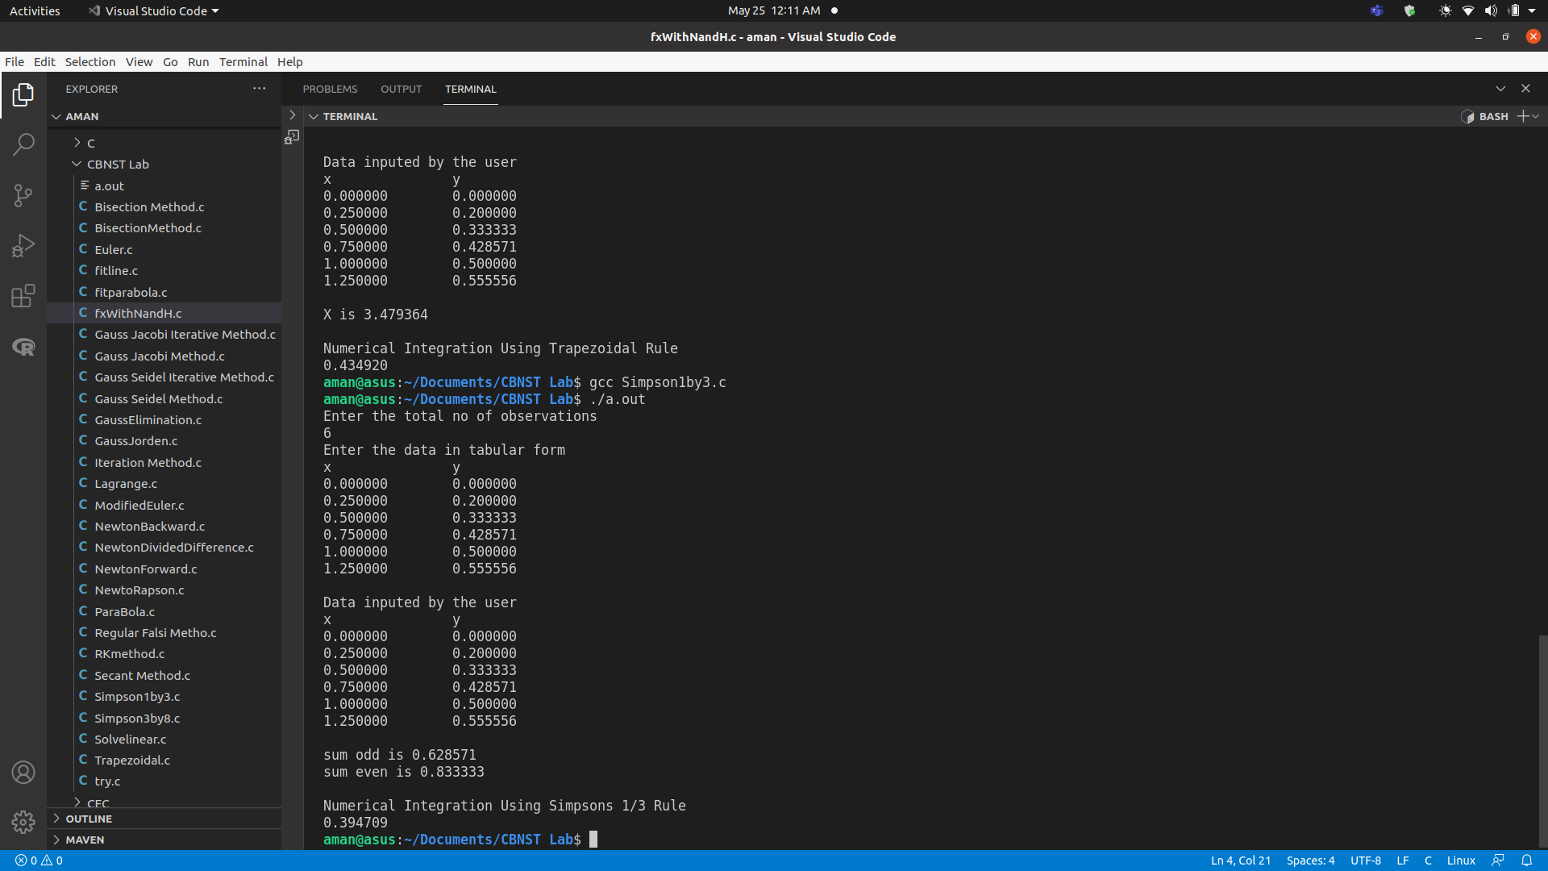

Program 16

Objective: Program to implement Simpson 3/8 rule.
Algorithm:
1.Given a function f(x):
2. (Get user inputs) Input a,b=endpoints of interval n=number of intervals
3. Set h= (b-a)/n.
4. Set sum=0.
5. Begin Fori= 1 to n -1 Set x =a + h*i. If i%3=0 Then Set sum=sum+2*f(x) Else Set sum=sum+3*f(x) End For
6. Set sum = sum + f(a)+f(b)
7. Set ans = sum*(3h/8)
8.End

Source Code
#include<stdio.h>

int main(void) {
printf("Enter the total no of observations\n");
int n, i, j;
scanf("%d",&n);
printf("Enter the data in tabular form\nx\t\ty \n");
double x[n], y[n], X, summod3=0, sumdiv3=0;
for(i=0;i<n;i++)
scanf("%lf%lf",&x[i],&y[i]);
printf("\nData inputed by the user\nx\t\ty\n");
for(i=0;i<n;i++)
printf("%lf\t%lf\n",x[i],y[i]);
X=y[0]+y[n-1];
for(i=1;i<n-1;i++) {
if(i%3==0)
sumdiv3+=y[i];
else
summod3+=y[i];
}
double h=x[1]-x[0];
printf("\nsum mod 3 is %lf\nsum div 3 is %lf\n",summod3,sumdiv3);
X=(y[0]+y[n-1]+3*summod3+2*sumdiv3)*3*h/8;
printf("\nNumerical Integration Using Simpson 3/8 Rule \n%lf\n",X);
return 0;
}
Output
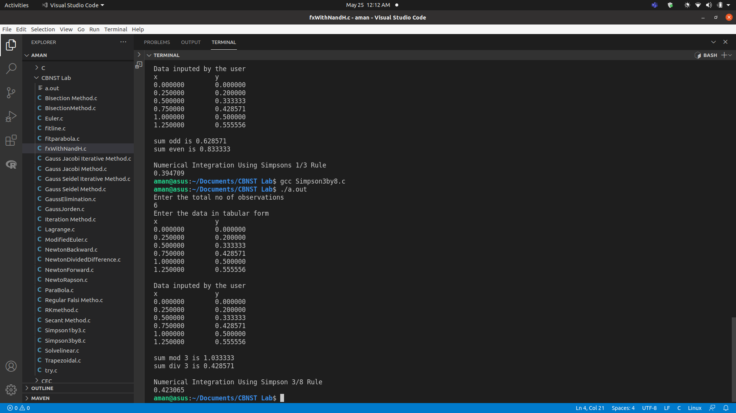

Program 17

Objective: Program to Fit a line.
Algorithm:
- Take two floating types of array. x[10] and y[10].
- Now take n as input from the user.
- Take x,y as input from the user with the help of for loop. (0<=i<n)
- Now find the values of Σx, Σy, Σxy, Σx^2 using for loop.
- Using the formula to solve the simultaneous equation solve for a and b. For formula have a look at Fig 2.
- Put the values of a and b in the equation of the straight line by checking the condition if b>0 or b=0.
- Print the result.

Source Code
#include<stdio.h>
#include<stdlib.h>

float* Solveliner(int n, float A[][n+1], float x[])//Using Gauss Jorden Method
{
int i, j, k, e, l, m;
if(n<=0)
{
if(n==0)
n=-1;
n=n*-1;
}
printf("\nMatrix\n");
for(i=0;i<n;i++)
{
for(j=0;j<=n;j++)
{
printf("%.4f\t\t",A[i][j]);
}
printf("\n");
}
float r;
for(i=0;i<n;i++)
{
for(j=0;j<n;j++)
{
if(j==i)
continue;
if(A[i][i]==0)
{
for(e=0;e<n;e++)
{
if(A[e][i]!=0)
{
for(k=0;k<=n;k++)
A[i][k]+=A[e][k];
}
}
}
r=A[j][i]/A[i][i];
for(k=0;k<=n;k++)
A[j][k]=A[j][k]-r*A[i][k];
}
printf("\nMatrix in step %d\n",i+1);
for(l=0;l<n;l++)
{
for(m=0;m<=n;m++)
{
printf("%.4f\t\t",A[l][m]);
}
printf("\n");
}
}
printf("\nDiagnoal Matrix\n");
for(i=0;i<n;i++)
{
for(j=0;j<=n;j++)
{
printf("%.4f\t\t",A[i][j]);
}
printf("\n");
}
float sum;
for(i=0;i<n;i++)
{
x[i]=A[i][n]/A[i][i];
}
return x;
}

int main(void)
{
printf("Enter the total no of observations\n");
int n, i, j;
scanf("%d",&n);
if (n<=0)
{
if(n==0)
n=-1;
n*=-1;
}
printf("Enter the data in tabular form\nx\t\ty \n");
double x[n], y[n], xy[n], xsq[n];
double sx,sy,sxy,sxsq;
sx=sy=sxy=sxsq=0;
for(i=0;i<n;i++) {
scanf("%lf%lf",&x[i],&y[i]);
xy[i]=x[i]*y[i];
xsq[i]=x[i]*x[i];
sx+=x[i];
sy+=y[i];
sxy+=xy[i];
sxsq+=xsq[i];
}
printf("\nTable\nx\t\ty\t\txy\t\tx^2\n");
for(i=0;i<n;i++)
printf("%f\t%f\t%f\t%f\n",x[i],y[i],xy[i],xsq[i]);
printf("\nSum\nx\t\ty\t\txy\t\tx^2\n");
printf("%f\t%f\t%f\t%f\n",sx,sy,sxy,sxsq);
printf("\nEquations\n");
printf("\n%lf a + %lf b = %lf", 1.0*n, sx, sy);
printf("\n%lf a + %lf b = %lf", sx, sxsq, sxy);
float Ar[2][3], r[2];
Ar[0][0]=n;
Ar[0][1]=sx;
Ar[0][2]=sy;
Ar[1][0]=sx;
Ar[1][1]=sxsq;
Ar[1][2]=sxy;
Solveliner(2,Ar,r);
printf("\nSolution\nY = %lf + %lf x\n",r[0],r[1]);
return 0;
}

Output
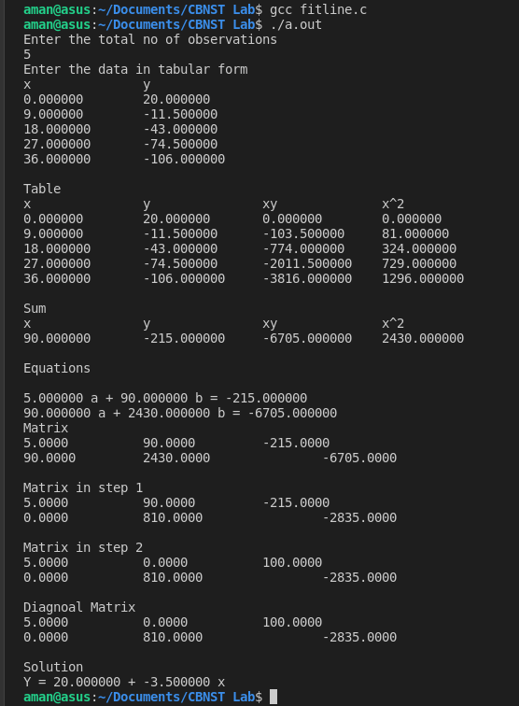
Program 18

Objective: Program to Fit a Parabola.
Algorithm:
- Read no. of data points n and order of polynomial Mp
- Read data values .
- If n<Mp [ Regression is not possible ] stop else continue ;
- Set M=Mp + 1 ;
- Compute co-efficient of C-matrix .
- Compute co-efficient of B-matrix .
- Solve for the co-efficients a1,a2,. . . . . . . an .
- Write the co-efficient .
- Estimate the function value at the glren of independents variables .

Source Code
#include<stdio.h>
#include<stdlib.h>

float* Solveliner(int n, float A[][n+1], float x[])//Using Gauss Jorden Method
{
int i, j, k, e, l, m;
if(n<=0)
{
if(n==0)
n=-1;
n=n*-1;
}
printf("\nMatrix\n");
for(i=0;i<n;i++)
{
for(j=0;j<=n;j++)
{
printf("%.4f\t\t",A[i][j]);
}
printf("\n");
}
float r;
for(i=0;i<n;i++)
{
for(j=0;j<n;j++)
{
if(j==i)
continue;
if(A[i][i]==0)
{
for(e=0;e<n;e++)
{
if(A[e][i]!=0)
{
for(k=0;k<=n;k++)
A[i][k]+=A[e][k];
}
}
}
r=A[j][i]/A[i][i];
for(k=0;k<=n;k++)
A[j][k]=A[j][k]-r*A[i][k];
}
printf("\nMatrix in step %d\n",i+1);
for(l=0;l<n;l++)
{
for(m=0;m<=n;m++)
{
printf("%.4f\t\t",A[l][m]);
}
printf("\n");
}
}
printf("\nDiagnoal Matrix\n");
for(i=0;i<n;i++)
{
for(j=0;j<=n;j++)
{
printf("%.4f\t\t",A[i][j]);
}
printf("\n");
}
float sum;
for(i=0;i<n;i++)
{
x[i]=A[i][n]/A[i][i];
}
return x;
}

int main(void)
{
printf("Enter the total no of observations\n");
int n, i, j;
scanf("%d",&n);
if (n<=0)
{
if(n==0)
n=-1;
n*=-1;
}
printf("Enter the data in tabular form\nx\t\ty \n");
double x[n], y[n], xy[n], x2[n], yx2[n], x3[n], x4[n];
double sx,sy,sxy,sx2, syx2, sx3, sx4;
sx=sy=sxy=sx2=syx2=sx3=sx4=0;
for(i=0;i<n;i++) {
scanf("%lf%lf",&x[i],&y[i]);
xy[i]=x[i]*y[i];
x2[i]=x[i]*x[i];
yx2[i]=y[i]*x2[i];
x3[i]=x[i]*x2[i];
x4[i]=x2[i]*x2[i];
sx+=x[i];
sy+=y[i];
sxy+=xy[i];
sx2+=x2[i];
syx2+=yx2[i];
sx3+=x3[i];
sx4+=x4[i];
}
printf("\nTable\nx\t\ty\t\txy\t\tx^2\t\tyx^2\t\tx^3\t\tx^4\n");
for(i=0;i<n;i++)
printf("%f\t%f\t%f\t%f\t%f\t%f\t%f\n",x[i],y[i],xy[i],x2[i],yx2[i],x3[i],x4[i]);
printf("\nSum\nx\t\ty\t\txy\t\tx^2\t\tyx^2\t\tx^3\t\tx^4\n");
printf("%f\t%f\t%f\t%f\t%f\t%f\t%f\n",sx,sy,sxy,sx2,syx2,sx3,sx4);
printf("\nEquations\n");
printf("\n%lf a + %lf b + %lf c = %lf", 1.0*n, sx, sx2, sy);
printf("\n%lf a + %lf b + %lf c = %lf", sx, sx2, sx3, sxy);
printf("\n%lf a + %lf b + %lf c = %lf", sx2, sx3, sx4, syx2);
float Ar[3][4], r[3];

Ar[0][0]=n;
Ar[0][1]=sx;
Ar[0][2]=sx2;
Ar[0][3]=sy;

Ar[1][0]=sx;
Ar[1][1]=sx2;
Ar[1][2]=sx3;
Ar[1][3]=sxy;

Ar[2][0]=sx2;
Ar[2][1]=sx3;
Ar[2][2]=sx4;
Ar[2][3]=syx2;

Solveliner(3,Ar,r);
printf("\nSolution\nY = %lf + %lf x + %lf x^2\n",r[0],r[1],r[2]);
return 0;
}

Output


